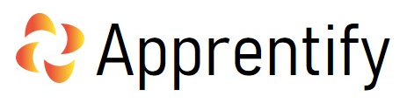

APPRENTICE APPEALS PROCEDURE
2021-2022

Prepared By: | Authorised by
MARK SIMPKINS | PAUL DREW
Date Sanctioned | AUGUST 2021
SIGNATURE/S: | 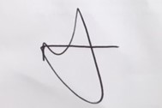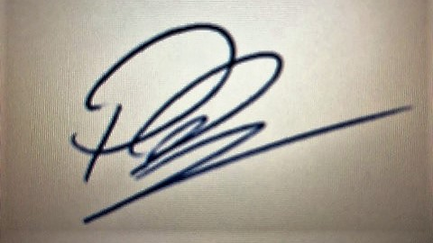

Board Signatures

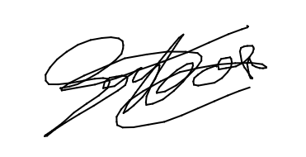
PAUL DREW GERWYN HOUSE

Appeals Procedure

From time to time, an Apprentice may feel aggrieved about not having reached the standard of competency expected.
Should an Apprentice wish to appeal, they should follow the Appeals Procedure set out below:
Stage One
- When an Apprentice feels that an assessment has been unfair, this must be conveyed to their Development Coach within five working days.
- The Apprentice will complete the Appeals Form, which they can complete via our website and submitted to the Quality team.
- Apprentify’s Internal Quality Assurer (IQA) will investigate the matter within 14 calendar days of receipt and respond accordingly. The decision will be noted. If resolved, the matter ends here.
- The completed form is then stored in Bud, and on OneDrive, for monitoring purposes.

If the matter remains unresolved, Stage 2 of the Appeals Procedure will be invoked:
Stage Two
- An email and copy of the Appeals form indicating that the matter is unresolved should be sent to Apprentify’s Head of Quality by the Internal Quality Assurer.
- Within 7 working days of the form being registered with the Head of Quality, arrangements will be made for an Appeal Hearing date.
- A panel of three people made up of Apprentify’s Managing Director, Head of Quality, and the Curriculum Manager, will hear the Appeal, and a decision will be reached and communicated to the Apprentice.
- If an Apprentice is still not satisfied and believes that Apprentify has not conducted the appeal in the agreed way, they can then take up the matter with the relevant Awarding Organisation. (For example: For BCS appeals, an apprentice can directly appeal to BCS within 20 days of the assessment if they are not satisfied with the outcome of Stage 1)

Review:

This policy will be reviewed annually or earlier if deemed necessary.

