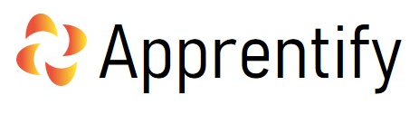

WHISTLEBLOWING POLICY
2021-2022

Prepared By: | Authorised by
PAUL DREW | MARK SIMPKINS
Date Sanctioned | AUGUST 2021
SIGNATURE/S: | 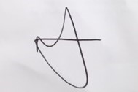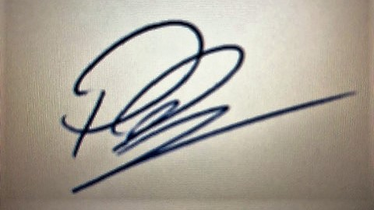

Board Signatures
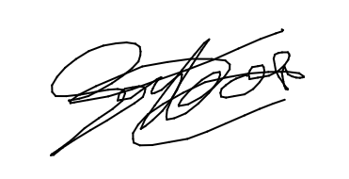
PAUL DREW GERWYN HOUSE

Purpose

Whistleblowing is when an individual knows, or suspects, that there is some wrongdoing occurring within the Company and alerts the employer or the relevant authority accordingly.
The Public Interest Disclosure Act 1998 gives protection to individuals, casual workers, agency workers and contractors who make a qualifying disclosure when they reasonably believe it is in the public interest for them to do so.

Actions to be taken by the individual

If an individual knows or suspects that some wrongdoing is occurring within the Company, s/he should raise the matter immediately with the relevant manager. If the individual does not know who to approach, s/he should, in the first instance, talk to his or her line manager.

Possible situations

Although this list is not exhaustive, examples of situations in which it might be appropriate for an individual to report a wrongdoing include:
- a breach, or potential breach, of health and safety legislation
- financial irregularities
- harassment of a colleague, customer or other individual
- damage to the environment
- the committing of a criminal offence
- an act of bribery
- deliberate concealment of any of the above.

Action to be taken by the manager

Any manager who is informed by an individual of potential wrongdoing will take immediate action to investigate the situation. In doing so, the manager will take every possible step to maintain the anonymity of the individual who has made the allegation of wrongdoing.
The individual who has raised the issue will be kept informed of any investigation that is taking place. The individual will also be informed of the outcome of the investigation. It might not always be appropriate to tell the individual the detail of any action that is taken, but the individual will be informed if action is taken.

Alerting outside bodies to a potential wrongdoing

An individual should always, in the first instance, talk to a manager in the Company about a potential wrongdoing. If the individual is not satisfied with the response, he or she is entitled to contact a relevant external body to express the concerns. In doing this, the individual should:
- have a reasonable belief that the allegation is based on correct facts
- make the disclosure to a relevant body
- have a reasonable belief it is in the public interest to make the disclosure.
A “relevant body” is likely to be a regulatory body (e.g. the Health and Safety Executive, or the Financial Conduct Authority).

Contacting the media

The media is not a relevant external body. Individuals should not contact the media with allegations about the Company, except in extraordinary circumstances where neither the Company nor the relevant regulatory body would be appropriate.

Protection against detriment

Any individual who acts under the Public Interest Disclosure Act 1998 will be protected from suffering any detriment in relation to the allegations that are made, including victimisation by the Company or by colleagues.
If the individual does not follow the procedure set out, which encompasses the requirements of the Public Disclosure Act 1998, the protection against detriment will not apply. Disclosing information in an inappropriate way (e.g. contacting the media) could result in disciplinary action being taken against the individual, which could include summary dismissal.

Review

This Policy will be reviewed on annually or earlier if deemed necessary.

